DS-LAB

INDEX
sno | List of Programs | Date
1. | R AS CALCULATOR APPLICATION  a. Using with and without R objects on console  b. Using mathematical functions on console  c. Write an R script, to create R objects for calculator application and save in a specified location in disk. | 10-09-25
2. | DESCRIPTIVE STATISTICS IN R  a. Write an R script to find basic descriptive statistics using summary, str, quartile function on mtcars& cars datasets.  b. Write an R script to find subset of dataset by using subset (), aggregate () functions on iris dataset | 10-09-25
3. | READING AND WRITING DIFFERENT TYPES OF DATASETS  a. Reading different types of data sets (.txt, .csv) from Web and disk and writing in file in specific disk location.  b. Reading Excel data sheet in R.  c. Reading XML dataset in R | 10-09-25
4. | VISUALIZATIONS  a. Find the data distributions using box and scatter plot.  b. Find the outliers using plot.  c. Plot the histogram, bar chart and pie chart on sample data | 08-10-25
5. | CORRELATION AND COVARIANCE  a. Find the correlation matrix.  b. Plot the correlation plot on dataset and visualize giving an overview of relationships among data on iris data.  c. Analysis of covariance: variance (ANOVA), if data have categorical variables on iris data | 17-09-25
6. | REGRESSION MODEL  Import a data from web storage. Name the dataset and now do Logistic Regression to find out relation between variables that are affecting the admission of a student in a institute based on his or her GRE score, GPA obtained and rank of the student. Also check the model is fit or not. Require (foreign), require (MASS) | 29-10-25
7. | MULTIPLE REGRESSION MODEL  Apply multiple regressions, if data have a continuous Independent variable. Apply on above dataset | 17-10-25
8. | REGRESSION MODEL FOR PREDICTION  Apply regression Model techniques to predict the data on above dataset | 12-11-25
9. | CLASSIFICATION MODEL  a. Install relevant package for classification.  b. Choose classifier for classification problem.  c. Evaluate the performance of classifier. | 12-11-25
10. | CLUSTERING MODEL  a. Clustering algorithms for unsupervised classification.  b. Plot the cluster data using R visualizations. | 13-11-25
11. | Write R program to find all elements of a given list that are not in another given list. | 13-11-25
12. | Write a R program to show plot using the mosaicplot() function. | 13-11-25
13. | Write a R program to show plot using stripchart() and QQ Plots | 13-11-25

LAB-1 (13-08-25)

BASIC OPERATIONS:
arithmetic:
> 10+20
[1] 30
> a<-10
> a
[1] 10
> b<-10
> sum<-a+b
> diff<-a-b
> prod<-a*b
> div<-a/b
> print(paste("sum",sum))
[1] "sum 20"
> print(paste("difference",diff))
[1] "difference 0"
> print(paste("product",prod))
[1] "product 100"
> print(paste("division",div))
[1] "division 1"
> iris
Sepal.Length Sepal.Width Petal.Length Petal.Width Species
1 5.1 3.5 1.4 0.2 setosa
2 4.9 3.0 1.4 0.2 setosa
3 4.7 3.2 1.3 0.2 setosa
4 4.6 3.1 1.5 0.2 setosa
5 5.0 3.6 1.4 0.2 setosa
6 5.4 3.9 1.7 0.4 setosa
7 4.6 3.4 1.4 0.3 setosa
8 5.0 3.4 1.5 0.2 setosa
9 4.4 2.9 1.4 0.2 setosa
10 4.9 3.1 1.5 0.1 setosa
11 5.4 3.7 1.5 0.2 setosa
12 4.8 3.4 1.6 0.2 setosa
13 4.8 3.0 1.4 0.1 setosa
14 4.3 3.0 1.1 0.1 setosa
15 5.8 4.0 1.2 0.2 setosa
16 5.7 4.4 1.5 0.4 setosa
17 5.4 3.9 1.3 0.4 setosa
18 5.1 3.5 1.4 0.3 setosa
19 5.7 3.8 1.7 0.3 setosa
20 5.1 3.8 1.5 0.3 setosa
21 5.4 3.4 1.7 0.2 setosa
22 5.1 3.7 1.5 0.4 setosa
23 4.6 3.6 1.0 0.2 setosa
24 5.1 3.3 1.7 0.5 setosa
25 4.8 3.4 1.9 0.2 setosa
26 5.0 3.0 1.6 0.2 setosa
27 5.0 3.4 1.6 0.4 setosa
28 5.2 3.5 1.5 0.2 setosa
29 5.2 3.4 1.4 0.2 setosa
30 4.7 3.2 1.6 0.2 setosa
31 4.8 3.1 1.6 0.2 setosa
32 5.4 3.4 1.5 0.4 setosa
33 5.2 4.1 1.5 0.1 setosa
34 5.5 4.2 1.4 0.2 setosa
35 4.9 3.1 1.5 0.2 setosa
36 5.0 3.2 1.2 0.2 setosa
37 5.5 3.5 1.3 0.2 setosa
38 4.9 3.6 1.4 0.1 setosa
39 4.4 3.0 1.3 0.2 setosa
40 5.1 3.4 1.5 0.2 setosa
41 5.0 3.5 1.3 0.3 setosa
42 4.5 2.3 1.3 0.3 setosa
43 4.4 3.2 1.3 0.2 setosa
44 5.0 3.5 1.6 0.6 setosa
45 5.1 3.8 1.9 0.4 setosa
46 4.8 3.0 1.4 0.3 setosa
47 5.1 3.8 1.6 0.2 setosa
48 4.6 3.2 1.4 0.2 setosa
49 5.3 3.7 1.5 0.2 setosa
50 5.0 3.3 1.4 0.2 setosa
51 7.0 3.2 4.7 1.4 versicolor
52 6.4 3.2 4.5 1.5 versicolor
53 6.9 3.1 4.9 1.5 versicolor
54 5.5 2.3 4.0 1.3 versicolor
55 6.5 2.8 4.6 1.5 versicolor
56 5.7 2.8 4.5 1.3 versicolor
57 6.3 3.3 4.7 1.6 versicolor
58 4.9 2.4 3.3 1.0 versicolor
59 6.6 2.9 4.6 1.3 versicolor
60 5.2 2.7 3.9 1.4 versicolor
61 5.0 2.0 3.5 1.0 versicolor
62 5.9 3.0 4.2 1.5 versicolor
63 6.0 2.2 4.0 1.0 versicolor
64 6.1 2.9 4.7 1.4 versicolor
65 5.6 2.9 3.6 1.3 versicolor
66 6.7 3.1 4.4 1.4 versicolor
67 5.6 3.0 4.5 1.5 versicolor
68 5.8 2.7 4.1 1.0 versicolor
69 6.2 2.2 4.5 1.5 versicolor
70 5.6 2.5 3.9 1.1 versicolor
71 5.9 3.2 4.8 1.8 versicolor
72 6.1 2.8 4.0 1.3 versicolor
73 6.3 2.5 4.9 1.5 versicolor
74 6.1 2.8 4.7 1.2 versicolor
75 6.4 2.9 4.3 1.3 versicolor
76 6.6 3.0 4.4 1.4 versicolor
77 6.8 2.8 4.8 1.4 versicolor
78 6.7 3.0 5.0 1.7 versicolor
79 6.0 2.9 4.5 1.5 versicolor
80 5.7 2.6 3.5 1.0 versicolor
81 5.5 2.4 3.8 1.1 versicolor
82 5.5 2.4 3.7 1.0 versicolor
83 5.8 2.7 3.9 1.2 versicolor
84 6.0 2.7 5.1 1.6 versicolor
85 5.4 3.0 4.5 1.5 versicolor
86 6.0 3.4 4.5 1.6 versicolor
87 6.7 3.1 4.7 1.5 versicolor
88 6.3 2.3 4.4 1.3 versicolor
89 5.6 3.0 4.1 1.3 versicolor
90 5.5 2.5 4.0 1.3 versicolor
91 5.5 2.6 4.4 1.2 versicolor
92 6.1 3.0 4.6 1.4 versicolor
93 5.8 2.6 4.0 1.2 versicolor
94 5.0 2.3 3.3 1.0 versicolor
95 5.6 2.7 4.2 1.3 versicolor
96 5.7 3.0 4.2 1.2 versicolor
97 5.7 2.9 4.2 1.3 versicolor
98 6.2 2.9 4.3 1.3 versicolor
99 5.1 2.5 3.0 1.1 versicolor
100 5.7 2.8 4.1 1.3 versicolor
101 6.3 3.3 6.0 2.5 virginica
102 5.8 2.7 5.1 1.9 virginica
103 7.1 3.0 5.9 2.1 virginica
104 6.3 2.9 5.6 1.8 virginica
105 6.5 3.0 5.8 2.2 virginica
106 7.6 3.0 6.6 2.1 virginica
107 4.9 2.5 4.5 1.7 virginica
108 7.3 2.9 6.3 1.8 virginica
109 6.7 2.5 5.8 1.8 virginica
110 7.2 3.6 6.1 2.5 virginica
111 6.5 3.2 5.1 2.0 virginica
112 6.4 2.7 5.3 1.9 virginica
113 6.8 3.0 5.5 2.1 virginica
114 5.7 2.5 5.0 2.0 virginica
115 5.8 2.8 5.1 2.4 virginica
116 6.4 3.2 5.3 2.3 virginica
117 6.5 3.0 5.5 1.8 virginica
118 7.7 3.8 6.7 2.2 virginica
119 7.7 2.6 6.9 2.3 virginica
120 6.0 2.2 5.0 1.5 virginica
121 6.9 3.2 5.7 2.3 virginica
122 5.6 2.8 4.9 2.0 virginica
123 7.7 2.8 6.7 2.0 virginica
124 6.3 2.7 4.9 1.8 virginica
125 6.7 3.3 5.7 2.1 virginica
126 7.2 3.2 6.0 1.8 virginica
127 6.2 2.8 4.8 1.8 virginica
128 6.1 3.0 4.9 1.8 virginica
129 6.4 2.8 5.6 2.1 virginica
130 7.2 3.0 5.8 1.6 virginica
131 7.4 2.8 6.1 1.9 virginica
132 7.9 3.8 6.4 2.0 virginica
133 6.4 2.8 5.6 2.2 virginica
134 6.3 2.8 5.1 1.5 virginica
135 6.1 2.6 5.6 1.4 virginica
136 7.7 3.0 6.1 2.3 virginica
137 6.3 3.4 5.6 2.4 virginica
138 6.4 3.1 5.5 1.8 virginica
139 6.0 3.0 4.8 1.8 virginica
140 6.9 3.1 5.4 2.1 virginica
141 6.7 3.1 5.6 2.4 virginica
142 6.9 3.1 5.1 2.3 virginica
143 5.8 2.7 5.1 1.9 virginica
144 6.8 3.2 5.9 2.3 virginica
145 6.7 3.3 5.7 2.5 virginica
146 6.7 3.0 5.2 2.3 virginica
147 6.3 2.5 5.0 1.9 virginica
148 6.5 3.0 5.2 2.0 virginica
149 6.2 3.4 5.4 2.3 virginica
150 5.9 3.0 5.1 1.8 virginica
Loops:
> x<-5
> for(i in 1:5)
+ print(paste("loop",i))
[1] "loop 1"
[1] "loop 2"
[1] "loop 3"
[1] "loop 4"
[1] "loop 5

> a<-6
> b<-0
> if(a>b){
+ print("a is big")
+ }else{
+ print("b is big")
+ }
[1] "a is big"

> score <- 85
> if (score >= 90) {
+ print("Grade: A")
+ } else if (score >= 75) {
+ print("Grade: B")
+ } else {
+ print("Grade: C")
+ }
[1] "Grade: B"

FUNCTIONS:
> add_numbers<-function(x,y){
+ return(x+y)
+ }
> result<-add_numbers(15,25)
> print(paste("result",result))
[1] "result 40"

> say_hello <- function() {
+ print("Hello from R!")
+ }
> say_hello()
[1] "Hello from R!"
VECTOR:
> vec<-c(1,2,3,4,5)
> print("original vector:")
[1] "original vector:"
> print(vec)
[1] 1 2 3 4 5
> print(paste("first element",vec[1]))
[1] "first element 1"
> print(paste("sum of the vector",sum(vec)))
[1] "sum of the vector 15"
> print(vec)
[1] 1 2 3 4 5
> print(vec[-1])
[1] 2 3 4 5
> print(vec[0:-2])
[1] 3 4 5
> print(vec[4])
[1] 4
> print(vec[0:-1])
[1] 2 3 4 5

LAB-2 (20-08-25)
MATHEMATICAL OPERATIONS:
> sqrt(5)
[1] 2.236068
> log(10)
[1] 2.302585
> log10(100)
[1] 2
> abs(-3)
[1] 3
> exp(5)
[1] 148.4132
> vec<-c(5,6,2,8)
> mean(vec)
[1] 5.25
> median(vec)
[1] 5.5
> var(vec)
[1] 6.25
> min(vec)
[1] 2
> max(vec)
[1] 8
> summary(vec)
Min. 1st Qu. Median Mean 3rd Qu. Max.
2.00 4.25 5.50 5.25 6.50 8.00

LIST:
> list_a=list(Name="adiba",Age=20,Scores=c(80,85,90))
> print(list_a$Name)
[1] "adiba"
> print(list_a$Age)
[1] 20
> print(list_a$Scores)
[1] 80 85 90
> list_a
$Name
[1] "adiba"
$Age
[1] 20
$Scores
[1] 80 85 90
> list_a$rno<-58
> list_a
$Name
[1] "adiba"
$Age
[1] 20

$Scores
[1] 80 85 90

$rno
[1] 58

DATAFRAME:
> d_f<-data.frame(names=c("adiba","hafsa","heena"),rno=c(58,71,60))
> print(d_f)
names rno
1 adiba 58
2 hafsa 71
3 heena 60
> str(d_f)
'data.frame': 3 obs. of 2 variables:
$ names: chr "adiba" "hafsa" "heena"
$ rno : num 58 71 60
> summary(d_f)
names rno
Length:3 Min. :58.0
Class :character 1st Qu.:59.0
Mode :character Median :60.0
Mean :63.0
3rd Qu.:65.5
Max. :71.0
> print(d_f$names)
[1] "adiba" "hafsa" "heena"
> print(d_f$rno)
[1] 58 71 60
> d_f$grade<-c("A","S","A")
> print(d_f)
names rno grade
1 adiba 58 A
2 hafsa 71 S
3 heena 60 A

TEXT FILE:
> data_txt<-read.table("D:/message.txt",header=TRUE,sep="\t")
> print(data_txt)
[1] HELLO.WORLD.
<0 rows> (or 0-length row.names)

CSV FILE:
> data_txt<-read.table("D:/student.csv",header=TRUE,sep=",")
> print(data_txt)
names marks
1 jerry 67
2 ron 89
3 tom 50

URL FILE:
> url<-"https://people.sc.fsu.edu/~jburkardt/data/csv/airtravel.csv"
> web_data<-read.csv(url,header=TRUE)
> print(web_data)
Month X1958 X1959 X1960
1 JAN 340 360 417
2 FEB 318 342 391
3 MAR 362 406 419
4 APR 348 396 461
5 MAY 363 420 472
6 JUN 435 472 535
7 JUL 491 548 622
8 AUG 505 559 606
9 SEP 404 463 508
10 OCT 359 407 461
11 NOV 310 362 390
12 DEC 337 405 432
MATRICES:
> m <- matrix(1:6, nrow = 2, ncol = 3)
> print(m)
[,1] [,2] [,3]
[1,] 1 3 5
[2,] 2 4 6
> m[1, 2]
[1] 3
> m[ , 3]
[1] 5 6
> m[2, ]
[1] 2 4 6

LAB-3 (10-09-25)

1.PERFORM SIMPLE ARITHMETIC OPERATIONS AND MATHEMATICAL OPERATION
ARITHMETIC OPERATIONS
> a<-c(1,2,3,4,5,6)
> a
[1] 1 2 3 4 5 6
> b<-c(3,9,20,4,7,8)
> cov<-cov(a,b)
> cov
[1] 0.3
> cor<-cor(a,b)
> cor
[1] 0.02632693
> std<-sd(a,na.rm=TRUE)
> std
[1] 1.870829
> #arithmetic operations
> a=3
> b=6
> sum<-(a+b)
> print("sum:",sum)
[1] "sum:"
> print(sum)
[1] 9
> diff<-(a-b)
> diff
[1] -3
> prod<-(a*b)
> prod
[1] 18
> div<-(a/b)
> div
[1] 0.5
MATHEMATICAL OPERATIONS
> v<-c(1,2,3,4,5,6)
> sqrt(v)
[1] 1.000000 1.414214 1.732051 2.000000 2.236068 2.449490
> abs(v)
[1] 1 2 3 4 5 6
> log(v)
[1] 0.0000000 0.6931472 1.0986123 1.3862944 1.6094379 1.7917595
> sin(v)
[1] 0.8414710 0.9092974 0.1411200 -0.7568025 -0.9589243 -0.2794155
> cos(v)
[1] 0.5403023 -0.4161468 -0.9899925 -0.6536436 0.2836622 0.9601703
> tan(v)
[1] 1.5574077 -2.1850399 -0.1425465 1.1578213 -3.3805150 -0.2910062

2.WORK WITH CONDITIONAL STATEMENTS(IF-ELSE),LOOPS(FOR & WHILE)
> x<-5
> for(i in 1:5)
+ print(paste("loop",i))
[1] "loop 1"
[1] "loop 2"
[1] "loop 3"
[1] "loop 4"
[1] "loop 5

> a<-6
> b<-0
> if(a>b){
+ print("a is big")
+ }else{
+ print("b is big")
+ }
[1] "a is big"

> x <- 1
> while (x <= 5) {
+ print(paste("x is", x))
+ x <- x + 1
+ }
[1] "x is 1"
[1] "x is 2"
[1] "x is 3"
[1] "x is 4"
[1] "x is 5"
> y<- 10
> while (y > 0) {
+ print(y)
+ y <- y - 2
+ }
[1] 10
[1] 8
[1] 6
[1] 4
[1] 2
> score <- 85
> if (score >= 90) {
+ print("Grade: A")
+ } else if (score >= 75) {
+ print("Grade: B")
+ } else {
+ print("Grade: C")
+ }
[1] "Grade: B"
3.Execute the sample program using functions
> add_numbers<-function(x,y){
+ return(x+y)
+ }
> result<-add_numbers(15,25)
> print(paste("result",result))
[1] "result 40"

> say_hello <- function() {
+ print("Hello from R!")
+ }
>
> say_hello()
[1] "Hello from R!"

4.Work with vectors and its operations
> vec<-c(1,2,3,4,5)
> print("original vector:")
[1] "original vector:"
> print(vec)
[1] 1 2 3 4 5
> print(paste("first element",vec[1]))
[1] "first element 1"
> print(paste("sum of the vector",sum(vec)))
[1] "sum of the vector 15"
> print(vec)
[1] 1 2 3 4 5
> print(vec[-1])
[1] 2 3 4 5
> print(vec[0:-2])
[1] 3 4 5
> print(vec[4])
[1] 4
> print(vec[0:-1])
[1] 2 3 4 5

5.Prepare the data sets - reading and uploading the CSV files from URL on the local drive upload and download (working with IRIS, MTCARS and TITANIC datasets)
> url_iris <- "https://raw.githubusercontent.com/uiuc-cse/data-fa14/gh-pages/data/iris.csv"
> local_iris <- "iris.csv"
> download.file(url_iris, destfile = local_iris)
trying URL 'https://raw.githubusercontent.com/uiuc-cse/data-fa14/gh-pages/data/iris.csv'
Content type 'text/plain; charset=utf-8' length 3716 bytes
downloaded 3716 bytes

> iris_data <- read.csv(local_iris)
> head(iris_data)
sepal_length sepal_width petal_length petal_width species
1 5.1 3.5 1.4 0.2 setosa
2 4.9 3.0 1.4 0.2 setosa
3 4.7 3.2 1.3 0.2 setosa
4 4.6 3.1 1.5 0.2 setosa
5 5.0 3.6 1.4 0.2 setosa
6 5.4 3.9 1.7 0.4 setosa
> mtcars_data <- read.csv("https://raw.githubusercontent.com/selva86/datasets/master/mtcars.csv")
> write.csv(mtcars_data, "mtcars.csv", row.names = FALSE)
> mtcars_local <- read.csv("mtcars.csv")
> head(mtcars_local)
mpg cyl disp hp drat wt qsec vs am gear carb fast cars carname
1 4.582576 6 160 110 3.90 2.620 16.46 0 1 4 4 1 Mazda RX4 Mazda RX4
2 4.582576 6 160 110 3.90 2.875 17.02 0 1 4 4 1 Mazda RX4 Wag Mazda RX4 Wag
3 4.774935 4 108 93 3.85 2.320 18.61 1 1 4 1 1 Datsun 710 Datsun 710
4 4.626013 6 258 110 3.08 3.215 19.44 1 0 3 1 1 Hornet 4 Drive Hornet 4 Drive
5 4.324350 8 360 175 3.15 3.440 17.02 0 0 3 2 1 Hornet Sportabout Hornet Sportabout
6 4.254409 6 225 105 2.76 3.460 20.22 1 0 3 1 1 Valiant Valiant
> titanic_data <- read.csv("https://raw.githubusercontent.com/datasciencedojo/datasets/master/titanic.csv")
> write.csv(titanic_data, "titanic.csv", row.names = FALSE)
> titanic_local <- read.csv("titanic.csv")
> head(titanic_local)
PassengerId Survived Pclass Name Sex Age SibSp Parch Ticket Fare Cabin Embarked
1 1 0 3 Braund, Mr. Owen Harris male 22 1 0 A/5 21171 7.2500 S
2 2 1 1 Cumings, Mrs. John Bradley (Florence Briggs Thayer) female 38 1 0 PC 17599 71.2833 C85 C
3 3 1 3 Heikkinen, Miss. Laina female 26 0 0 STON/O2. 3101282 7.9250 S
4 4 1 1 Futrelle, Mrs. Jacques Heath (Lily May Peel) female 35 1 0 113803 53.1000 C123 S
5 5 0 3 Allen, Mr. William Henry male 35 0 0 373450 8.0500 S
6 6 0 3 Moran, Mr. James male NA 0 0 330877 8.4583 Q

6.Implement Descriptive statistics functions (str, summary, Quantile, Standard Deviation and dim names) - any of the data sets and central tendency functions
> df<-data.frame(name<-c("adiba","heena","hafsa","safa"),
+ marks<-c(90,80,85,95),rollno<-c(58,60,71,78))
> str(df)
'data.frame': 4 obs. of 3 variables:
$ name....c..adiba....heena....hafsa....safa..: chr "adiba" "heena" "hafsa" "safa"
$ marks....c.90..80..85..95. : num 90 80 85 95
$ rollno....c.58..60..71..78. : num 58 60 71 78
> summary(df)
name....c..adiba....heena....hafsa....safa.. marks....c.90..80..85..95. rollno....c.58..60..71..78.
Length:4 Min. :80.00 Min. :58.00
Class :character 1st Qu.:83.75 1st Qu.:59.50
Mode :character Median :87.50 Median :65.50
Mean :87.50 Mean :66.75
3rd Qu.:91.25 3rd Qu.:72.75
Max. :95.00 Max. :78.00
> dim(df)
[1] 4 3
> df
name....c..adiba....heena....hafsa....safa.. marks....c.90..80..85..95. rollno....c.58..60..71..78.
1 adiba 90 58
2 heena 80 60
3 hafsa 85 71
4 safa 95 78
> sd(df$rollno,na.rm=TRUE)
[1] 9.429563
7. Perform the data cleaning operations on any of the data sets for
a. Count missing:
> sum(is.na(df))
[1] 0
> df<-data.frame(name<-c("adiba","heena","hafsa","safa"),
+ marks<-c(90,80,85,NA),rollno<-c(58,60,71,NA))
> sum(is.na(df))
[1] 2
b. Replace NA with mean
> mean_value<-mean(df$marks,na.rm=TRUE)
> df
name....c..adiba....heena....hafsa....safa.. marks....c.90..80..85..NA. rollno....c.58..60..71..NA.
1 adiba 90 58
2 heena 80 60
3 hafsa 85 71
4 safa NA NA
> df$marks[is.na(df$marks)]<-mean_value
> df
name....c..adiba....heena....hafsa....safa.. marks....c.90..80..85..NA. rollno....c.58..60..71..NA. marks
1 adiba 90 58 90
2 heena 80 60 80
3 hafsa 85 71 85
4 safa NA NA 85
> mean_value_column<-mean(df$rollno,na.rm=TRUE)
> df$rollno[is.na(df$rollno)]<-mean_value_column
> df
name....c..adiba....heena....hafsa....safa.. marks....c.90..80..85..NA. rollno....c.58..60..71..NA. marks rollno
1 adiba 90 58 90 58
2 heena 80 60 80 60
3 hafsa 85 71 85 71
4 safa NA NA 85 63
c. Remove duplicates
df1<-data.frame(fruits<-c("apple","lichi","lichi","mango","strawberry","banana","banana"),price<-c(30,70,70,50,90,100,100))
> df1
fruits....c..apple....lichi....lichi....mango....strawberry... price....c.30..70..70..50..90..100..100.
1 apple 30
2 lichi 70
3 lichi 70
4 mango 50
5 strawberry 90
6 banana 100
7 banana 100
> unique(df1)
fruits....c..apple....lichi....lichi....mango....strawberry... price....c.30..70..70..50..90..100..100.
1 apple 30
2 lichi 70
4 mango 50
5 strawberry 90
6 banana 100
d. Convert data types
> x<-c(2,5)
> class(x)
[1] "numeric"
> y<-as.character(x)
> y
[1] "2" "5"
e. Handle outliers
(i)
> df1$price<-(df1$price-min(df1$price))/(max(df1$price)-min(df1$price))
> df1
fruits....c..apple....lichi....lichi....mango....strawberry... price....c.30..70..70..50..90..100..100. price
1 apple 30 0.0000000
2 lichi 70 0.5714286
3 lichi 70 0.5714286
4 mango 50 0.2857143
5 strawberry 90 0.8571429
6 banana 100 1.0000000
7 banana 100 1.0000000
(ii) IQR method:
> Q1<-quantile(df$marks, 0.25)
> Q2<-quantile(df$marks, 0.25)
> IQR<-Q2-Q1
> print(IQR)
25%
f. Feature scaling
> df1$sno<-c(1,2,3,4,5,6,7)
> df1
fruits....c..apple....lichi....lichi....mango....strawberry... price....c.30..70..70..50..90..100..100. price sno
1 apple 30 0.0000000 1
2 lichi 70 0.5714286 2
3 lichi 70 0.5714286 3
4 mango 50 0.2857143 4
5 strawberry 90 0.8571429 5
6 banana 100 1.0000000 6
7 banana 100 1.0000000 7
> df1$sno<-scale(df1$sno)
> df1
fruits....c..apple....lichi....lichi....mango....strawberry... price....c.30..70..70..50..90..100..100. price sno
1 apple 30 0.0000000 -1.3887301
2 lichi 70 0.5714286 -0.9258201
3 lichi 70 0.5714286 -0.4629100
4 mango 50 0.2857143 0.0000000
5 strawberry 90 0.8571429 0.4629100
6 banana 100 1.0000000 0.9258201
7 banana 100 1.0000000 1.3887301

> df$scaled_col <- (df$marks - min(df$marks)) / (max(df$marks) - min(df$marks))
> df$scaled_col
[1] 1.0 0.0 0.5 0.5
g. Standardization
> df1$std_col <- scale(df1$sno)
> df1$std_col
[,1]
[1,] -1.3887301
[2,] -0.9258201
[3,] -0.4629100
[4,] 0.0000000
[5,] 0.4629100
[6,] 0.9258201
[7,] 1.3887301
attr(,"scaled:center")
[1] 0
attr(,"scaled:scale")
[1] 1

h. Encode categorical
> dataset
names....c..tom....alice....bob...1. salary....c.1000..20000..30000..40000. age st_col age_encoded
1 tom 1000 20 -0.9271726 1
2 alice 20000 45 1.0596259 3
3 bob 30000 30 -0.1324532 2
4 1 40000 NA NA NA
> dataset$age_encoded <- as.numeric(factor(dataset$age))
> dataset$age_encoded
[1] 1 3 2 NA

i. Training and split
> df 2<- data.frame(
+ name = c("Alice", "Bob", "Charlie", "Diana", "Evan"),
+ marks = c(90, 85, 78, 92, 88)
> set.seed(123)
> sample_size <- floor(0.8 * nrow(df))
> train_indices <- sample(seq_len(nrow(df)), size = sample_size)
>
> train_data <- df[train_indices, ]
> test_data <- df[-train_indices, ]
> print(train_data)
name marks
3 Charlie 78
2 Bob 85
5 Evan 88
4 Diana 92
> print(test_data)
name marks
1 Alice 90
> sum(is.na(iris))
[1] 0

LAB-4 (17-09-25)
8.Perform the following data transformation operations on any of the data sets(IRIS,MTCARS,TITANIC datasets)
a.Creating new columns
> iris$Sepal.Area <- iris$Sepal.Length * iris$Sepal.Width
> iris$Sepal.Area
[1] 17.85 14.70 15.04 14.26 18.00 21.06 15.64 17.00 12.76 15.19 19.98 16.32 14.40 12.90 23.20
[16] 25.08 21.06 17.85 21.66 19.38 18.36 18.87 16.56 16.83 16.32 15.00 17.00 18.20 17.68 15.04
[31] 14.88 18.36 21.32 23.10 15.19 16.00 19.25 17.64 13.20 17.34 17.50 10.35 14.08 17.50 19.38
[46] 14.40 19.38 14.72 19.61 16.50 22.40 20.48 21.39 12.65 18.20 15.96 20.79 11.76 19.14 14.04
b.Sorting
> sort(iris$Sepal.Length)
[1] 4.3 4.4 4.4 4.4 4.5 4.6 4.6 4.6 4.6 4.7 4.7 4.8 4.8 4.8 4.8 4.8 4.9 4.9 4.9 4.9 4.9 4.9
[23] 5.0 5.0 5.0 5.0 5.0 5.0 5.0 5.0 5.0 5.0 5.1 5.1 5.1 5.1 5.1 5.1 5.1 5.1 5.1 5.2 5.2 5.2
[45] 5.2 5.3 5.4 5.4 5.4 5.4 5.4 5.4 5.5 5.5 5.5 5.5 5.5 5.5 5.5 5.6 5.6 5.6 5.6 5.6 5.6 5.7
[67] 5.7 5.7 5.7 5.7 5.7 5.7 5.7 5.8 5.8 5.8 5.8 5.8 5.8 5.8 5.9 5.9 5.9 6.0 6.0 6.0 6.0 6.0
[89] 6.0 6.1 6.1 6.1 6.1 6.1 6.1 6.2 6.2 6.2 6.2 6.3 6.3 6.3 6.3 6.3 6.3 6.3 6.3 6.3 6.4 6.4
[111] 6.4 6.4 6.4 6.4 6.4 6.5 6.5 6.5 6.5 6.5 6.6 6.6 6.7 6.7 6.7 6.7 6.7 6.7 6.7 6.7 6.8 6.8
[133] 6.8 6.9 6.9 6.9 6.9 7.0 7.1 7.2 7.2 7.2 7.3 7.4 7.6 7.7 7.7 7.7 7.7 7.9
c.Merging and joining
> m_iris<-merge(iris$Sepal.Length,iris$Petal.Length)
> head(m_iris)
x y
1 5.1 1.4
2 4.9 1.4
3 4.7 1.4
4 4.6 1.4
5 5.0 1.4
6 5.4 1.4
> sepal_length <- data.frame(Row = 1:nrow(iris), Sepal.Length = iris$Sepal.Length)
> sepal_width <- data.frame(Row = 1:nrow(iris), Sepal.Width = iris$Sepal.Width)
> lj <- left_join(sepal_length, sepal_width, by = "Row")
> head(lj)
Row Sepal.Length Sepal.Width
1 1 5.1 3.5
2 2 4.9 3.0
3 3 4.7 3.2
4 4 4.6 3.1
5 5 5.0 3.6
6 6 5.4 3.9

d.Aggregation and Grouping
> result <- aggregate(iris$Sepal.Length ~iris$Sepal.Width,FUN = mean)
> result
> head(result)
iris$Sepal.Width iris$Sepal.Length
1 2.0 5.000000
2 2.2 6.066667
3 2.3 5.325000
4 2.4 5.300000
5 2.5 5.762500
6 2.6 6.160000
> result <- iris %>%
+ group_by(Species) %>%
+ summarize(Mean.Sepal.Length = mean(Sepal.Length))
> head(result)
Species Mean.Sepal.Length
<fct> <dbl>
1 setosa 5.01
2 versicolor 5.94
3 virginica 6.59

e.Exporting data
> ex<-write.csv(result,"iris_new.csv")
> ex
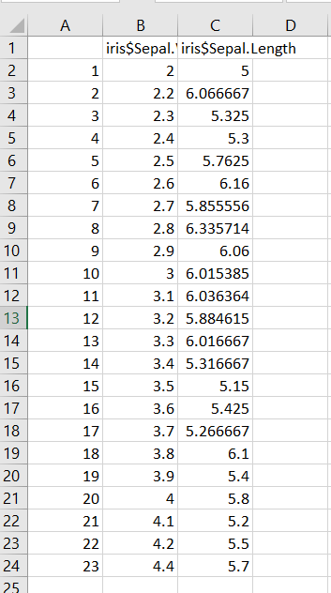

9.Implement EDA operations on any of the
datasets(IRIS.MTCARSandTITANIC) datasets
a.sum of missing values
> s<-sum(is.na(iris))
> head(s)
[1] 0

b.standard deviations
> sd(iris$Sepal.Length)
[1] 0.8280661

c.covariance
> cov(iris$Sepal.Length,iris$Sepal.Width)
[1] -0.042434

d.correlations
> cor(iris$Sepal.Length,iris$Sepal.Width)
[1] -0.1175698

e.skewness
> apply(mtcars,2,skewness)
mpg cyl disp hp drat wt qsec
0.6106550 -0.1746119 0.3816570 0.7260237 0.2659039 0.4231465 0.3690453
vs am gear carb
0.2402577 0.3640159 0.5288545 1.0508738

f.kutosis
> apply(mtcars,2,kurtosis)
mpg cyl disp hp drat wt
-0.37276603 -1.76211977 -1.20721195 -0.13555112 -0.71470062 -0.02271075
qsec vs am gear carb
0.33511422 -2.00193762 -1.92474143 -1.06975068 1.25704307

g.normal or gaussian distribution
>install.packages(“ggplot2”)
>library(ggplot2)
> ggplot(iris,aes(x=Petal.Length)) +
+ geom_density(fill="yellow",alpha=0.5) +
+ labs(title="iris",x="what",y="why")

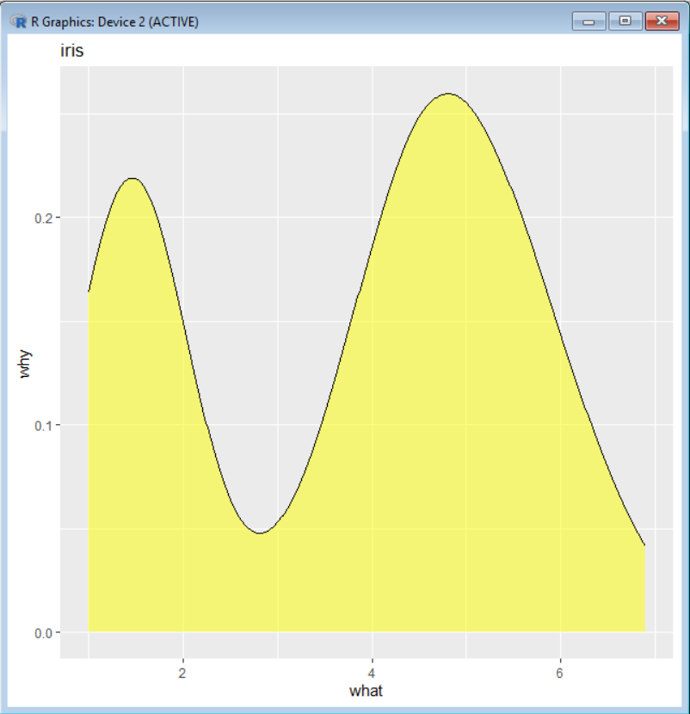

12.Find the covariance and correlation for theIRIS/MTCARS/TITANIC Data sets
> corr<-cor(iris$Sepal.Length,iris$Sepal.Width)
> corr
[1] -0.1175698
> corr<-cor(iris$Sepal.Length,iris$Petal.Width)
> corr
[1] 0.8179411
> cov_iris<-cov(iris$Sepal.Length,iris$Petal.Length)
> cov_iris
[1] 1.274315
> corr_m<-cor(mtcars$mpg,mtcars$cyl)
> corr_m
[1] -0.852162
> cov_m<-cov(mtcars$mpg,mtcars$cyl)
> cov_m
[1] -9.172379
> corr_t<-cor(titanic_data$PassengerId,titanic_data$Survived)
> corr_t
[1] -0.005006661
> cov_t<-cov(titanic_data$PassengerId,titanic_data$Survived)
> cov_t
[1] -0.62696

LAB-5 (08-10-25)
10.Perform the following visualization operations on any of the vector using ggplot2 library

a.SCATTERED GRAPH
library(ggplot2)

df <- data.frame(x = 1:10, y = c(2, 4, 5, 7, 6, 8, 9, 10, 12, 13))
ggplot(df, aes(x = x, y = y)) +
geom_point(color = "pink", size = 3) +
labs(title = "Scatter Plot ",
x = "X Axis", y = "Y Axis") +
theme_minimal()
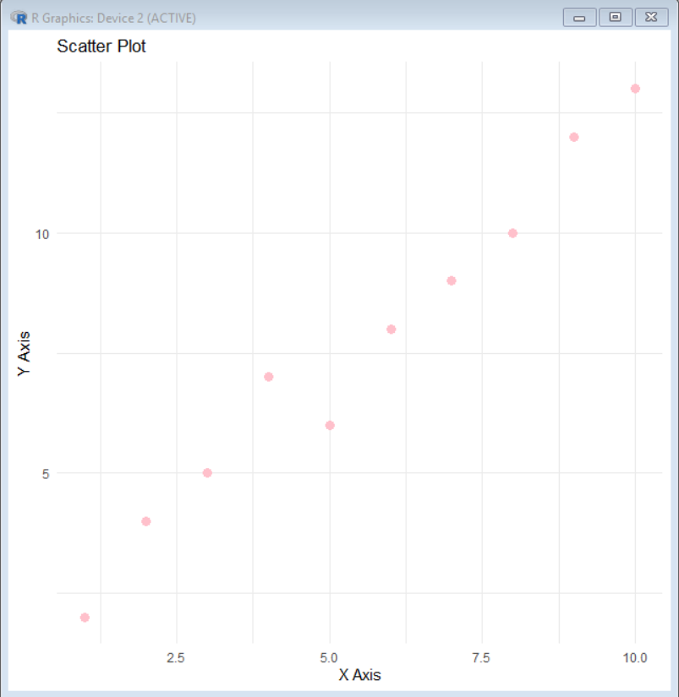

b.LINE GRAPH
> library(ggplot2)
> df <- data.frame(
+ x = 1:10,
+ y = c(2, 4, 5, 7, 6, 8, 9, 10, 12, 13)
+ )
> ggplot(df, aes(x = x, y = y)) +
+ geom_line(color = "yellow", size= 1.2) +
+ labs(title = "Line Graph",
+ x = "X Axis", y = "Y Axis") +
+ theme_minimal()
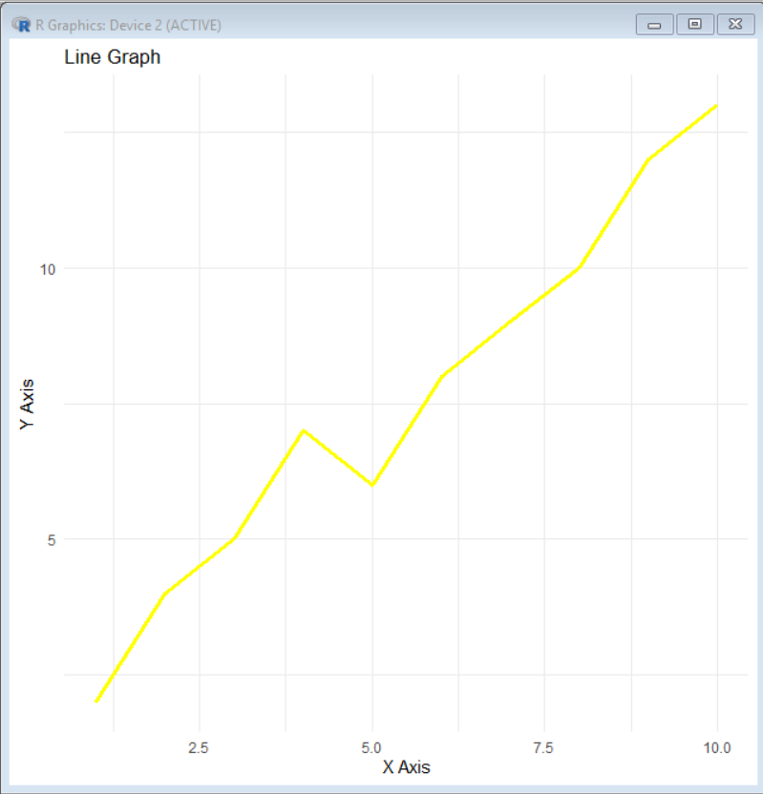
c.BAR PLOT:
library(ggplot2)
df <- data.frame(
student_name = c("A", "B", "C", "D"),
marks= c(5, 12, 9, 4)
)

ggplot(df, aes(x = student_name, y = marks)) +
geom_bar(stat = "identity", fill = "pink", color = "yellow") +
labs(title = "Bar Plot",
x = "student_name", y = " marks") +
theme_minimal()
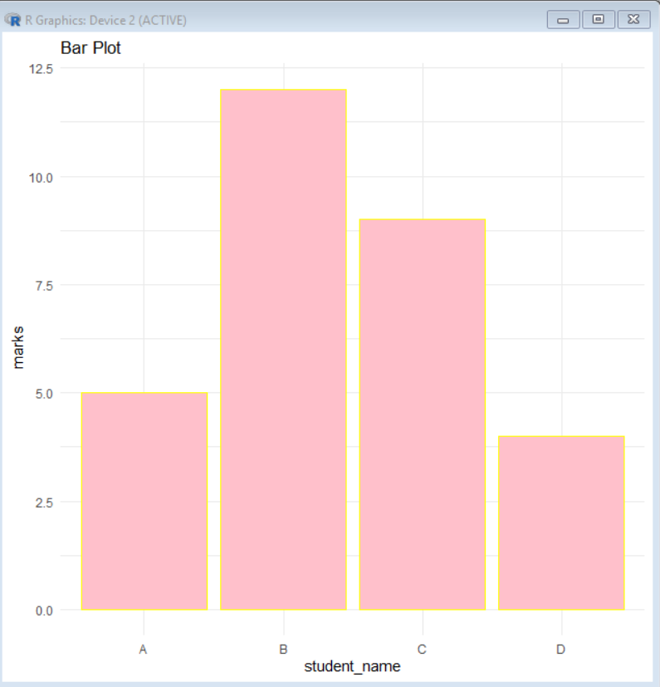

d.LINE AND SCATTERED PLOT GRAPH
x <- 1:10
y <- c(2, 4, 5, 7, 6, 8, 9, 10, 12, 13)
plot(x, y, pch = 19, col = "red",
main = "Line and Scatter Plot",
xlab = "X Axis", ylab = "Y Axis")
lines(x, y, col = "pink", lwd = 2)

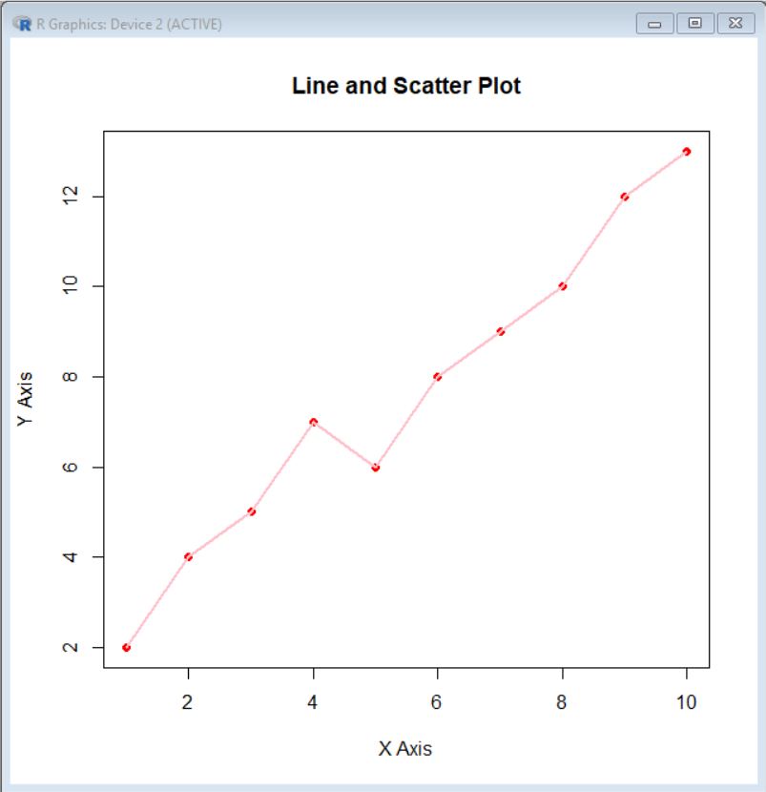

e.BOX PLOT
library(ggplot2)
df <- data.frame(
group = rep(c("A", "B", "C"), each = 20),
values = c(rnorm(20, 5), rnorm(20, 7), rnorm(20, 6))
)
ggplot(df, aes(x = group, y = values, fill = group)) +
geom_boxplot() +
labs(title = "Box Plot",
x = "Group", y = "Values") +
theme_minimal()
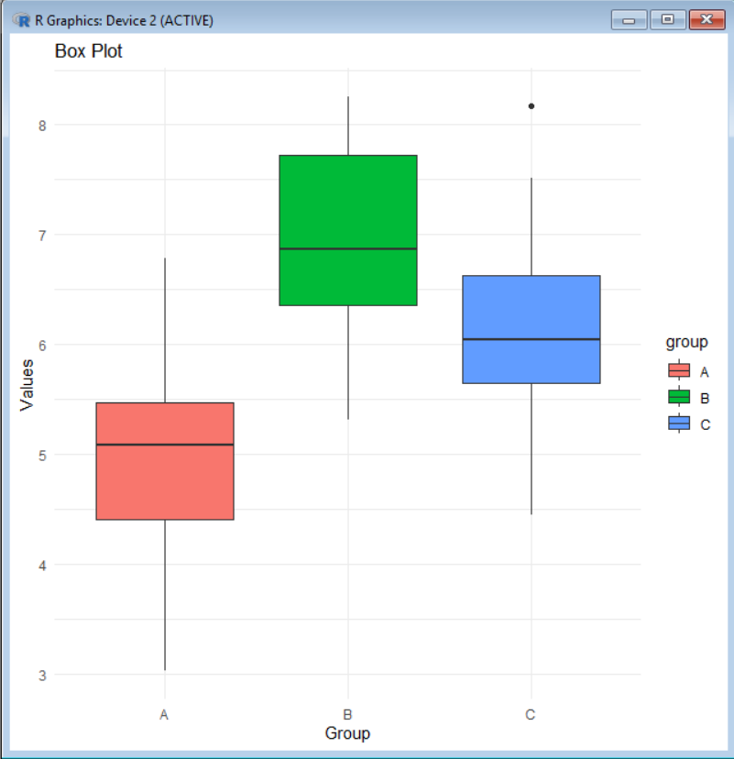

f.HISTOGRAM
library(ggplot2)
set.seed(123)
data <- rnorm(100, mean = 50, sd = 10)
df <- data.frame(value = data)
ggplot(df, aes(x = value)) +
geom_histogram(binwidth = 5, fill = "pink", color = "black") +
labs(title = "Histogram (ggplot2)", x = "Value", y = "Count") +
theme_minimal()
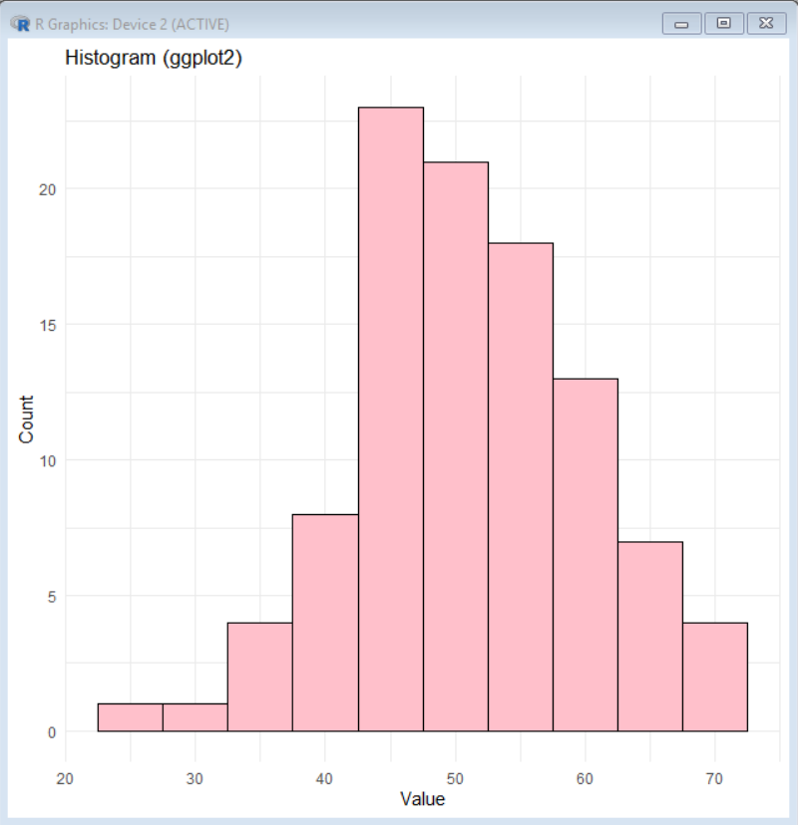

g.PIE CHART
library(ggplot2)
df_pie <- data.frame(
category = c("A", "B", "C", "D"),
count = c(10, 20, 30, 40)
)
ggplot(df_pie, aes(x = "", y = count, fill = category)) +
geom_bar(stat = "identity", width = 1) +
coord_polar(theta = "y") + # for angle
labs(title = "Pie Chart (ggplot2)") +
theme_void()
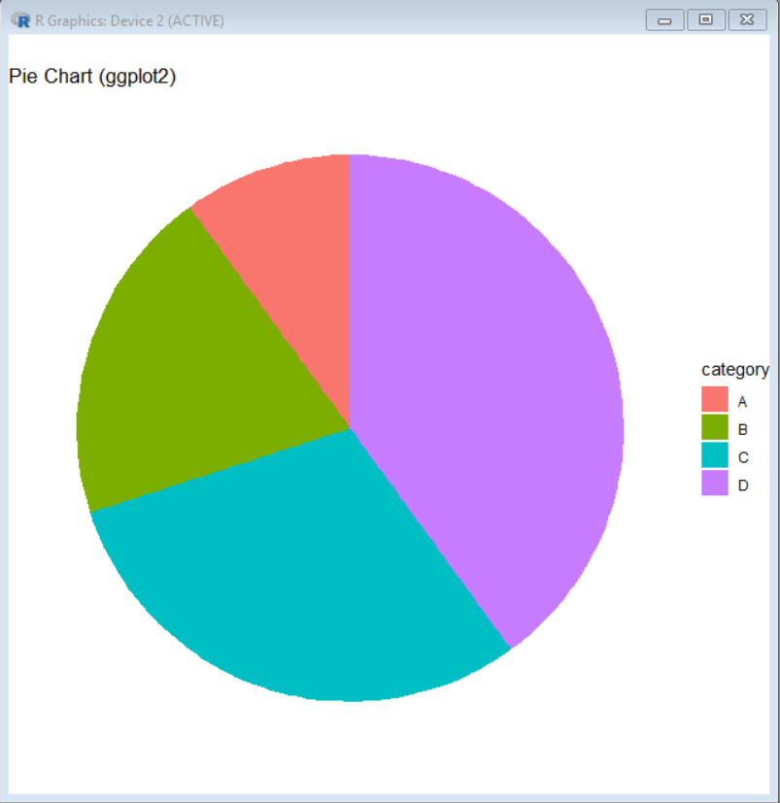

LAB-6 (17-10-25)
13.perform the simple linear regression(univariate analysis) on any data set.
> x<-c(1,2,3,4,5)
> y<-c(2,4,5,4,5)
> data<-data.frame(x,y)
> model<-lm(y~x,data=data)
> summary(model)
> plot(data$x,data$y,main="simple linear regression",xlab="x values",ylab="y values",pch=19,col="blue")
> abline(model,col="red",lwd=2)
> new_x<-data.frame(x=c(6,7,8))
> prediction<-predict(model,new_model=new_x)
> print(prediction)
output:Call:
lm(formula = y ~ x, data = data)

Residuals:
1 2 3 4 5
-0.8 0.6 1.0 -0.6 -0.2

Coefficients:
Estimate Std. Error t value Pr(>|t|)
(Intercept) 2.2000 0.9381 2.345 0.101
x 0.6000 0.2828 2.121 0.124

Residual standard error: 0.8944 on 3 degrees of freedom
Multiple R-squared: 0.6, Adjusted R-squared: 0.4667
F-statistic: 4.5 on 1 and 3 DF, p-value: 0.124
1 2 3 4 5
2.8 3.4 4.0 4.6 5.2

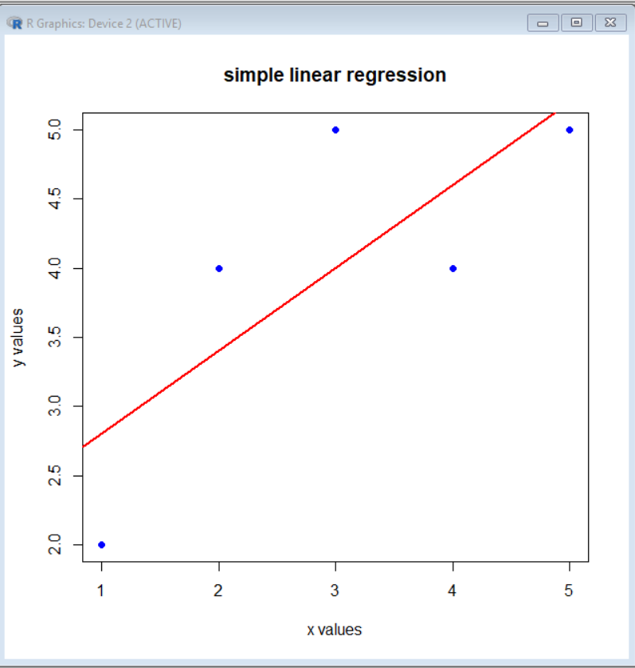

–Simple linear regression on mtcars dataset
> x<-mtcars$mpg
> y<-mtcars$qsec
> data<-data.frame(x,y)
> model<-lm(y~x,data=data)
> summary(model)
output:
Call:
lm(formula = y ~ x, data = data)

Residuals:
Min 1Q Median 3Q Max
-2.8161 -1.0287 0.0954 0.8623 4.7149

Coefficients:
Estimate Std. Error t value Pr(>|t|)
(Intercept) 15.35477 1.02978 14.911 2.05e-15 ***
x 0.12414 0.04916 2.525 0.0171 *
---
Signif. codes: 0 ‘***’ 0.001 ‘**’ 0.01 ‘*’ 0.05 ‘.’ 0.1 ‘ ’ 1

Residual standard error: 1.65 on 30 degrees of freedom
Multiple R-squared: 0.1753, Adjusted R-squared: 0.1478
F-statistic: 6.377 on 1 and 30 DF, p-value: 0.01708

> plot(data$x,data$y,main="simple linear regression on mtcars",xlab="X values",ylab="Y lab",pch=19,col="blue")
> abline(model,col="red",lwd=2)
> new_x<-data.frame(x=c(6,7,8))
> prediction<-predict(model,new_model=new_x)
> print(prediction)

output:

1 2 3 4 5 6 7 8
17.96164 17.96164 18.18508 18.01129 17.67612 17.60164 17.12992 18.38370
9 10 11 12 13 14 15 16
18.18508 17.73819 17.56440 17.39061 17.50233 17.24164 16.64579 16.64579
17 18 19 20 21 22 23 24
17.17958 19.37679 19.12852 19.56300 18.02370 17.27889 17.24164 17.00579
25 26 27 28 29 30 31 32
17.73819 18.74370 18.58232 19.12852 17.31613 17.80026 17.21682 18.01129
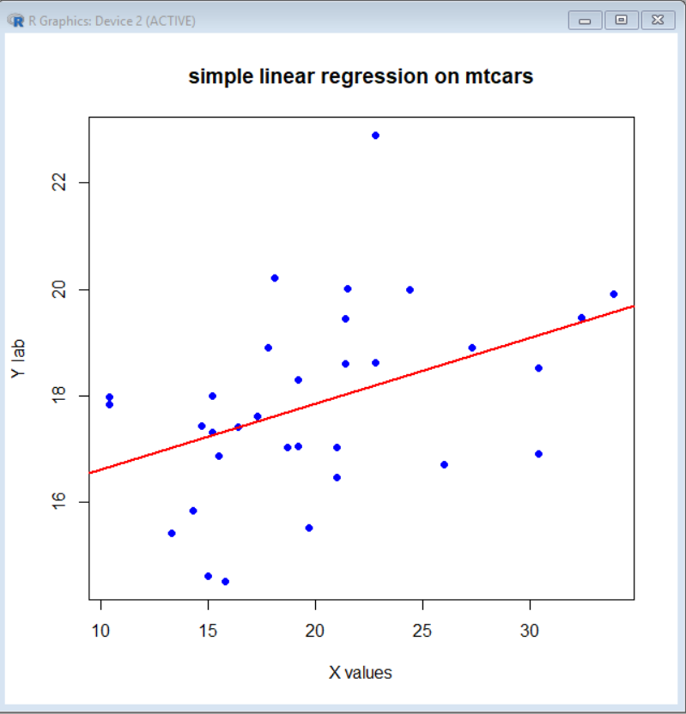

14.perform the multiple linear regression (bivariate analysis)on any of the data set.
> x<-c(1,2,3,4,5)
> y<-c(2,4,5,4,5)
> data<-data.frame(x,y)
> mean_x<-mean(x)
> mean_y<-mean(y)
> cov_xy<-cov(x,y)
> var_x<-var(x)
> var_y<-var(y)
> sd_x<-sd(x)
> sd_y<-sd(y)
> r<-cor(x,y)

> cat("mean of y:",mean_y,"\n")
mean of y: 4
> cat("covariance:",cov_xy,"\n")
covariance: 1.5
> cat("standard deviations:",sd_x,sd_y,"\n")
standard deviations: 1.581139 1.224745 )
correlation(r): 0.7745967
> model<-lm(y~x,data=data)
> summary(model)
output:
Call:
lm(formula = y ~ x, data = data)

Residuals:
1 2 3 4 5
-0.8 0.6 1.0 -0.6 -0.2

Coefficients:
Estimate Std. Error t value Pr(>|t|)
(Intercept) 2.2000 0.9381 2.345 0.101
x 0.6000 0.2828 2.121 0.124

Residual standard error: 0.8944 on 3 degrees of freedom
Multiple R-squared: 0.6, Adjusted R-squared: 0.4667
F-statistic: 4.5 on 1 and 3 DF, p-value: 0.124

> plot(data$x,data$y,main="Bivariate analysis:scatter+regression line",xlab="X values",ylab="Y values",pch=9,col="red")
> abline(model,col="blue",lwd=2)
> cor.test(x,y,method="pearson")
output:

Pearson's product-moment correlation

data: x and y
t = 2.1213, df = 3, p-value = 0.124
alternative hypothesis: true correlation is not equal to 0
95 percent confidence interval:
-0.3400820 0.9842358
sample estimates:
cor
0.7745967

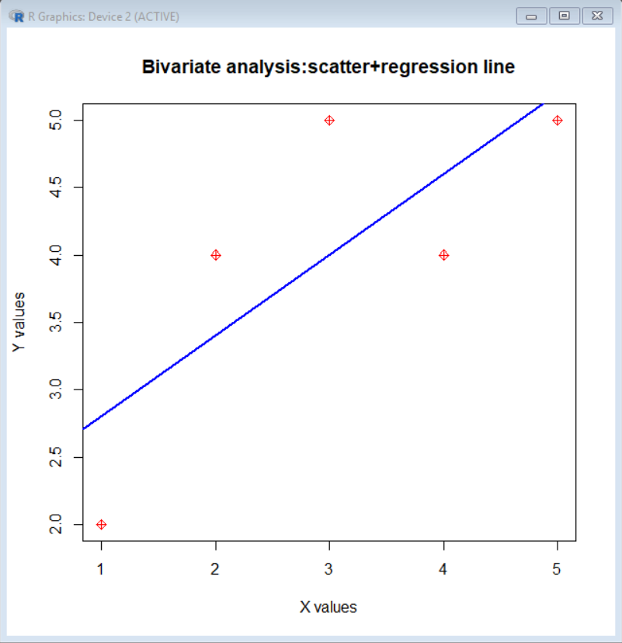

–Bivariate analysis on mtcars dataset:
> x<-mtcars$mpg
> y<-mtcars$disp
> data<-data.frame(x,y)
> mean_x<-mean(x)
> mean_y<-mean(y)
> cov_xy<-cov(x,y)
> var_x<-var(x)
> var_y<-var(y)
> sd_x<-sd(x)
> sd_y<-sd(y)
> r<-cor(x,y)
> cat("mean of y:",mean_y,"\n")
mean of y: 230.7219
> cat("covariance:",cov_xy,"\n")
covariance: -633.0972
> cat("standard deviations:",sd_x,sd_y,"\n")
standard deviations: 6.026948 123.9387
> cat("standard deviations:",sd_x,sd_y,"\n")
standard deviations: 6.026948 123.9387
> model<-lm(y~x,data=data)
> cat("correlation(r):",r,"\n\n")
correlation(r): -0.8475514

> summary(model)

Call:
lm(formula = y ~ x, data = data)

Residuals:
Min 1Q Median 3Q Max
-103.05 -45.74 -8.17 46.65 153.75

Coefficients:
Estimate Std. Error t value Pr(>|t|)
(Intercept) 580.884 41.740 13.917 1.26e-14 ***
x -17.429 1.993 -8.747 9.38e-10 ***
---
Signif. codes: 0 ‘***’ 0.001 ‘**’ 0.01 ‘*’ 0.05 ‘.’ 0.1 ‘ ’ 1

Residual standard error: 66.86 on 30 degrees of freedom
Multiple R-squared: 0.7183, Adjusted R-squared: 0.709
F-statistic: 76.51 on 1 and 30 DF, p-value: 9.38e-10

> plot(data$x,data$y,main="Bivariate analysis:scatter+regression line",xlab="X values",ylab="Y values",pch=9,col="red")
> abline(model,col="blue",lwd=2)
> cor.test(x,y,method="pearson")

Pearson's product-moment correlation

data: x and y
t = -8.7472, df = 30, p-value = 9.38e-10
alternative hypothesis: true correlation is not equal to 0
95 percent confidence interval:
-0.9233594 -0.7081376
sample estimates:
cor
-0.8475514
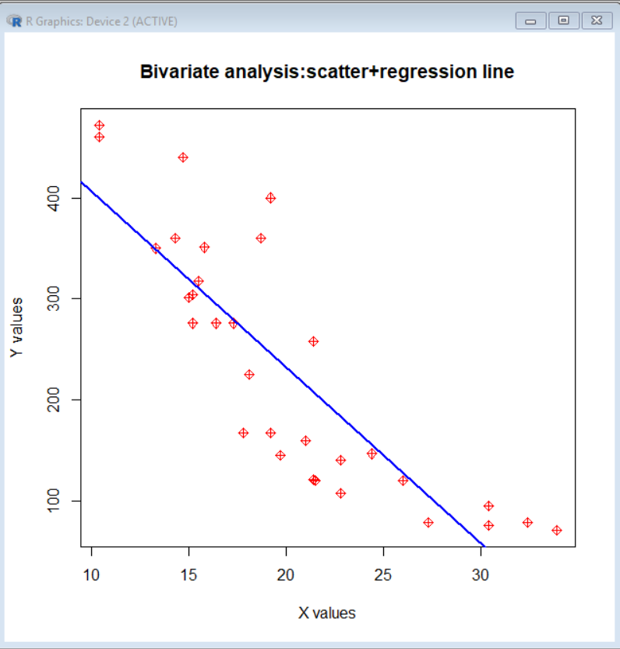

LAB-7 (24-10-25)
> new_mpg<-mtcars$mpg>20
> print(new_mpg)
[1] TRUE TRUE TRUE TRUE FALSE FALSE FALSE TRUE TRUE FALSE FALSE FALSE
[13] FALSE FALSE FALSE FALSE FALSE TRUE TRUE TRUE TRUE FALSE FALSE FALSE
[25] FALSE TRUE TRUE TRUE FALSE FALSE FALSE TRUE
> new_cyl<-(mtcars$cyl)
> new_cyl
[1] 6 6 4 6 8 6 8 4 4 6 6 8 8 8 8 8 8 4 4 4 4 8 8 8 8 4 4 4 8 6 8 4
> colnames(mtcars<-c("mpg","new_mpg"))
NULL

> df<-data.frame(
+ id=1:5,
+ age=c(25,29,30,22,28))
> print(df)
id age
1 1 25
2 2 29
3 3 30
4 4 22
5 5 28
> colnames(df<-c("id","id-rno"))
NULL
> print(df)
[1] "id" "id-rno"
> print(df)
[1] "id" "id-rno"
> colnames(df<-c("rno","age"))
NULL
> df
[1] "rno" "age"
> df2<-data.frame (x=c(1,2,2,4),y=c(4,5,8,0))
> merge(df,df2)
[1] x y
<0 rows> (or 0-length row.names)
> df2<-data.frame (rno=c(1,2,3,4,5),y=c(4,5,8,0,1))
> merge(df,df2)
x rno y
1 rno 1 4
2 age 1 4
3 rno 2 5
4 age 2 5
5 rno 3 8
6 age 3 8
7 rno 4 0
8 age 4 0
9 rno 5 1
10 age 5 1
arguments imply differing number of rows: 5, 4
> df<-data.frame(id=1:5,age=c(21,NA,25,NA,30))
> is.na(df)
id age
[1,] FALSE FALSE
[2,] FALSE TRUE
[3,] FALSE FALSE
[4,] FALSE TRUE
[5,] FALSE FALSE
> na.omit(df)
id age
1 1 21
3 3 25
5 5 30
> x=9
> y=5

> print(paste("addition:",x+y)
+ )
[1] "addition: 14"
> print(paste("subtraction:",x-y))
[1] "subtraction: 4"
> print(paste("multiplication:",x*y))
[1] "multiplication: 45"
> print(paste("division:",x/y))
[1] "division: 1.8"
> print(paste("power:",x^y))
[1] "power: 59049"
> print(paste("factorial",factorial(x)))
[1] "factorial 362880"

> library(ggplot2)
> x<-iris$Sepal.Length
> y<-iris$Petal.Length
> df<-data.frame(x,y)
> ggplot(df, aes(x,y)) +
+ geom_line(color = "blue") +
+ labs(title = "scatter graph in ggplot2",
+ x = "X Axis", y = "Y Axis") +
+ theme_minimal()
>

> x<-mtcars$V13
> y<-mtcars$V14
> mean_x<-(mean_x)
> mean_y<-(mean_y)
> mean_x<-(mean(x))

> data<-data.frame(x,y)
> mean_x<-mean(x)
> x<-iris$Sepal.Length
> y<-iris$Petal.Length
> data<-data.frame(x,y)
> mean_x<-mean(x)
> mean_y<-mean(y)
> cov_xy<-cov(x,y)
> var_x<-var(x)
> var_y<-var(y)
> sd_x<-sd(x)
> sd_y<-sd(y)
> r<-cor(x,y)
> cat("mean of X:",mean_x,"\n")
mean of X: 5.843333
> cat("mean of Y:",mean_y,"\n")
mean of Y: 3.758
> cat("covariance of Y:",cov_xy,"\n")
covariance of Y: 1.274315
> cat("standard deviation of x and y:",sd_x,sd_y,"\n")
standard deviation of x and y: 0.8280661 1.765298
> cat("correlation:",r,"\n\n")
correlation: 0.8717538

> model<-lm(y~x,data=data)
> summary(model)

Call:
lm(formula = y ~ x, data = data)

Residuals:
Min 1Q Median 3Q Max
-2.47747 -0.59072 -0.00668 0.60484 2.49512

Coefficients:
Estimate Std. Error t value Pr(>|t|)
(Intercept) -7.10144 0.50666 -14.02 <2e-16 ***
x 1.85843 0.08586 21.65 <2e-16 ***
---
Signif. codes: 0 ‘***’ 0.001 ‘**’ 0.01 ‘*’ 0.05 ‘.’ 0.1 ‘ ’ 1

Residual standard error: 0.8678 on 148 degrees of freedom
Multiple R-squared: 0.76, Adjusted R-squared: 0.7583
F-statistic: 468.6 on 1 and 148 DF, p-value: < 2.2e-16

> plot(data$x,data$y,main="correlation matrix and relationship btw variables",xlab="X values",ylab="Y values",pch=19,col="blue")
> abline(model,col="red"lwd=2)
Error: unexpected symbol in "abline(model,col="red"lwd"
> abline(model,col="red",lwd=2)
> cor.test(x,y,method="pearson")

Pearson's product-moment correlation

data: x and y
t = 21.646, df = 148, p-value < 2.2e-16
alternative hypothesis: true correlation is not equal to 0
95 percent confidence interval:
0.8270363 0.9055080
sample estimates:
cor
0.8717538

LAB-8 (29-10-25)
LOGISTIC REGRESSION ON SPAM DETECTION
spam_dataset=data.frame(values=c("lottery","meeting","bigwin","class","chance","hello","location","lunch","free","order"),spam_v=c(1,0,1,0,1,0,0,0,1,0))
> spam_dataset
values spam_v
1 lottery 1
2 meeting 0
3 bigwin 1
4 class 0
5 chance 1
6 hello 0
7 location 0
8 lunch 0
9 free 1
10 order 0
> model<-glm(spam_v~values,data=spam_datset,family=binomial)
> summary(model)

Call:
glm(formula = spam_v ~ values, family = binomial, data = spam_datset)

Coefficients:
Estimate Std. Error z value Pr(>|z|)
(Intercept) 2.457e+01 1.310e+05 0 1
valueschance -1.151e-06 1.853e+05 0 1
valuesclass -4.913e+01 1.853e+05 0 1
valuesfree -1.100e-06 1.853e+05 0 1
valueshello -4.913e+01 1.853e+05 0 1
valueslocation -4.913e+01 1.853e+05 0 1
valueslottery -1.102e-06 1.853e+05 0 1
valueslunch -4.913e+01 1.853e+05 0 1
valuesmeeting -4.913e+01 1.853e+05 0 1
valuesorder -4.913e+01 1.853e+05 0 1

(Dispersion parameter for binomial family taken to be 1)

Null deviance: 1.3460e+01 on 9 degrees of freedom
Residual deviance: 4.2867e-10 on 0 degrees of freedom
AIC: 20

Number of Fisher Scoring iterations: 23

> predicted_probs<-predict(model,type="response")
> predicted_class<-ifelse(predicted_probs>0.5,1,0)
> results<-cbind(spam_dataset,predicted_prob=round(predicted_probs,2),predicted_class=predicted_class)
> print(paste("predictions:",results))
[1] "predictions: c(\"lottery\", \"meeting\", \"bigwin\", \"class\", \"chance\", \"hello\", \"location\", \"lunch\", \"free\", \"order\")"
[2] "predictions: c(1, 0, 1, 0, 1, 0, 0, 0, 1, 0)"
[3] "predictions: c(1, 0, 1, 0, 1, 0, 0, 0, 1, 0)"
[4] "predictions: c(1, 0, 1, 0, 1, 0, 0, 0, 1, 0)"
> accuracy<-mean(results$spam_v==results$predicted_class)
> cat("model accuracy:",accuracy,"\n")
model accuracy: 1
>library(ggplot2)
> ggplot(results, aes(x = values, y = predicted_prob)) +
+ geom_point(aes(color = as.factor(spam_v)), size = 3) +
+ geom_line(color = "blue", aes(group = 1)) +
+ ggtitle("Logistic Regression: Probability of Getting a Spam Mail") +
+ xlab("Values") +
+ ylab("Predicted Probability") +
+ theme_minimal()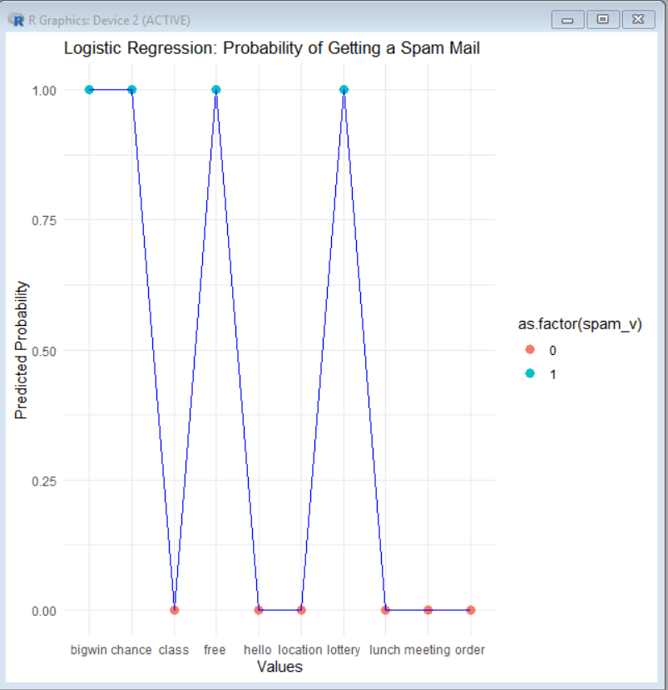LOGISTIC REGRESSION ON HEART DATASET
heart_data=data.frame(age=c(25,30,35,40,45,50,55,60,65,70),cholestrol=c(180,190,200,210,220,230,250,260,280,300),heart_disease=c(0,0,0,0,1,1,1,1,1,1))
> model<-glm(heart_disease~age+cholestrol,data=heart_data,family=binomial)
Warning message:
glm.fit: fitted probabilities numerically 0 or 1 occurred
> summary(model)

Call:
glm(formula = heart_disease ~ age + cholestrol, family = binomial,
data = heart_data)

Coefficients:
Estimate Std. Error z value Pr(>|z|)
(Intercept) 6.013e+02 1.682e+06 0 1
age 2.459e+01 5.444e+04 0 1
cholestrol -7.657e+00 1.835e+04 0 1

(Dispersion parameter for binomial family taken to be 1)

Null deviance: 1.3460e+01 on 9 degrees of freedom
Residual deviance: 3.5993e-10 on 7 degrees of freedom
AIC: 6

Number of Fisher Scoring iterations: 25

> predicted_probs<-predict(model,type="response")
> predicted_class<-ifelse(predicted_probs>0.5,1,0)
> results<-cbind(heart_data,predicted_prob=round(predicted_probs,2),predicted_class=predicted_class)
> print(paste("predictions:",results))
[1] "predictions: c(25, 30, 35, 40, 45, 50, 55, 60, 65, 70)"
[2] "predictions: c(180, 190, 200, 210, 220, 230, 250, 260, 280, 300)"
[3] "predictions: c(0, 0, 0, 0, 1, 1, 1, 1, 1, 1)"
[4] "predictions: c(0, 0, 0, 0, 1, 1, 1, 1, 1, 1)"
[5] "predictions: c(0, 0, 0, 0, 1, 1, 1, 1, 1, 1)"
> accuracy<-mean(results$heart_disease==results$predicted_class)
> cat("model accuracy:",accuracy,"\n")
model accuracy: 1
> library(ggplot2)
> ggplot(results, aes(x = age, y = predicted_prob)) +
+ geom_point(size = 3, color = "darkred") +
+ geom_line(aes(group = 1), color = "blue") +
+ ggtitle("Logistic Regression: Probability of Heart Disease vs Age") +
+ xlab("Age (years)") +
+ ylab("Predicted Probability") +
+ theme_minimal()
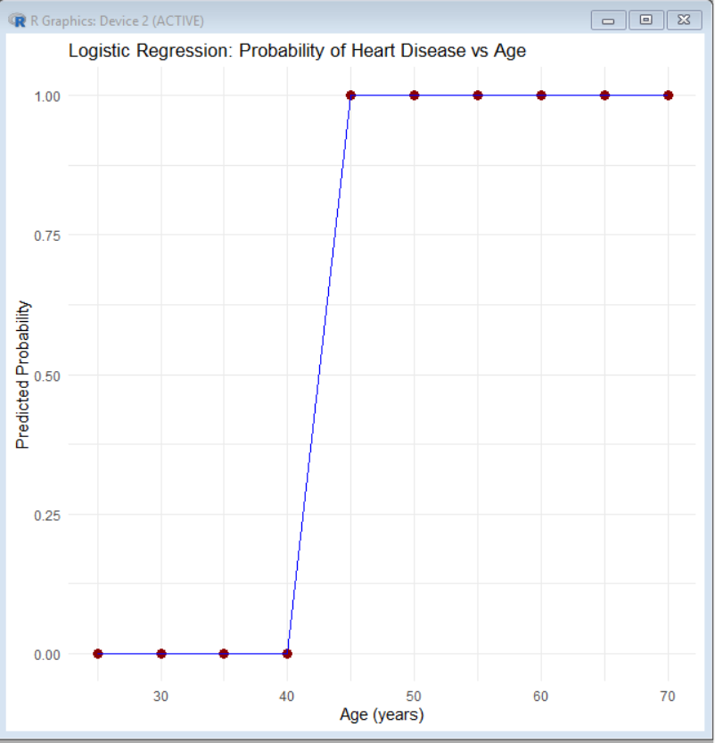

LAB-9 (12-11-25)

k-Nearest Neighbour (for classification) :
> install.packages("class")
Installing package into ‘C:/Users/Student/AppData/Local/R/win-library/4.3’
(as ‘lib’ is unspecified)
--- Please select a CRAN mirror for use in this session ---
trying URL 'https://cran.csiro.au/bin/windows/contrib/4.3/class_7.3-23.zip'
Content type 'application/zip' length 98579 bytes (96 KB)
downloaded 96 KB

package ‘class’ successfully unpacked and MD5 sums checked

The downloaded binary packages are in
C:\Users\Student\AppData\Local\Temp\RtmpsZKOSM\downloaded_packages
> library(class)
> data <- data.frame(
+ Height = c(5.0, 5.5, 5.8, 6.0, 5.2),
+ Weight = c(50, 60, 65, 70, 75),
+ class = c("A", "A", "B", "B", "A")
+ )
>
> train_data <- data[, c("Height", "Weight")]
> train_labels<-data$class
> test_data<-data.frame(Height=5.7,Weight=63)
> pred<-knn(train=train_data,test=test_data,cl=train_labels,k=3)
> print(pred)
[1] B
Levels: A B

k-Nearest Neighbour (for Regression) :
> install.packages("FNN")
Installing package into ‘C:/Users/Student/AppData/Local/R/win-library/4.3’
(as ‘lib’ is unspecified)
trying URL 'https://cran.csiro.au/bin/windows/contrib/4.3/FNN_1.1.4.1.zip'
Content type 'application/zip' length 458843 bytes (448 KB)
downloaded 448 KB

package ‘FNN’ successfully unpacked and MD5 sums checked

The downloaded binary packages are in
C:\Users\Student\AppData\Local\Temp\RtmpsZKOSM\downloaded_packages
> library(FNN)
> data <- data.frame(
+ Height = c(5.0, 5.5, 5.8, 6.0, 5.2),
+ Weight = c(50, 60, 65, 70, 75),
+ Score =c(80,85,90,95,82)
+ )
> train_data<-data[,c("Height","Weight")]
> train_target<-data$Score
> test_data<-data.frame(Height=5.7,Weight=63)
> pred<-knn.reg(train=train_data,test=test_data,y=train_target,k=3)
> print(pred$pred)
[1] 90

KNN-Clustering Model:
library(ggplot2)
set.seed(123)
data <- data.frame(
x = c(rnorm(50, 2, 0.5), rnorm(50, 5, 0.5)),
y = c(rnorm(50, 2, 0.5), rnorm(50, 5, 0.5))
)
k_means <- kmeans(data, centers = 2)
data$cluster <- as.factor(k_means$cluster)
ggplot(data, aes(x = x, y = y, color = cluster)) +
geom_point(size = 3) +
labs(
title = "K-means Clustering Visualization",
x = "Feature X",
y = "Feature Y"
) + theme_minimal()
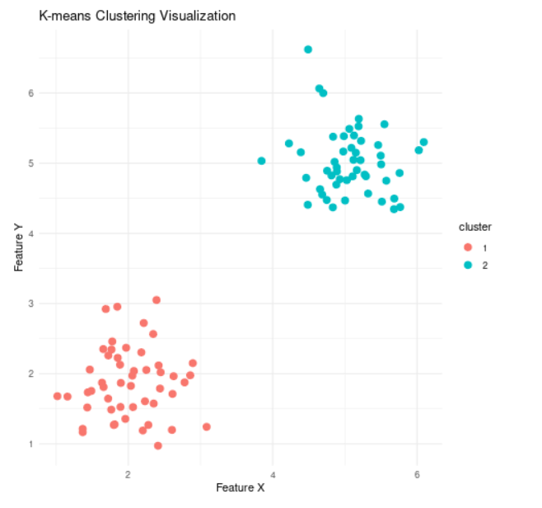

11.Write R program to find all elements of a given list that are not in another given list

list1<-c(1,2,3,4,5)
list2<-c(3,4,6,7)
result=setdiff(list1,list2)
print("Elements in list 1 but not in list2:")
print(result)
output:
"Elements in list 1 but not in list2:" 1 2 5

12.Write a R program to show plot using the mosaicplot() function.
gender <- c("Male", "Female", "Male", "Female", "Male", "Female", "Male", "Female")
preference <- c("Tea", "Coffee", "Tea", "Tea", "Coffee", "Coffee", "Tea", "Coffee")
data_table <- table(gender, preference)
mosaicplot(data_table,main="Mosaic plot of gender vs preference",color=TRUE)

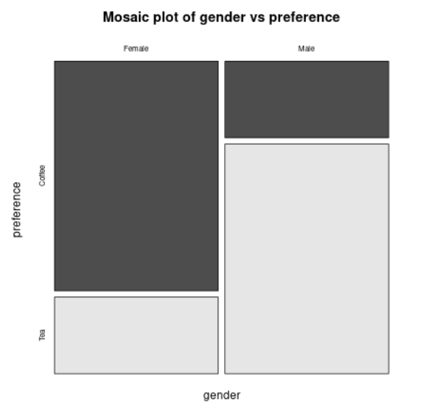
13.Write a R program to show plot using stripchart() and QQ Plots
value <- c(10, 12, 15, 18, 21, 22, 23, 25, 26)
stripchart(value,
main = "Strip chart example",
method = "stack",
col = "blue",
pch = 18)
set.seed(100)
data <- rnorm(50, mean = 5, sd = 2)

qqnorm(data, main = "QQ Plot for Normal Data")
qqline(data, col = "blue")

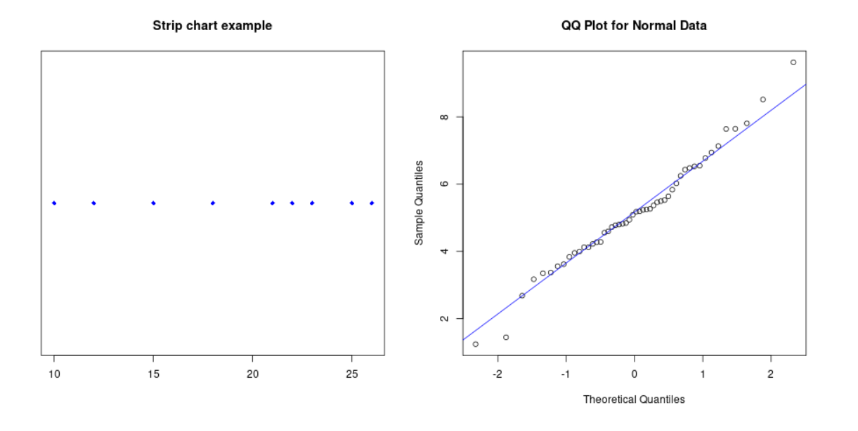
ADDITIONAL PROGRAMS:
TIME SERIES ANALYSIS USING R:
sales <- c(120, 130, 150, 160, 170, 180,
200, 210, 190, 180, 170, 160)
ts_sales <- ts(sales, start = c(2024, 1), frequency = 12)
print("Time Series Data:")
print(ts_sales)
plot(ts_sales,
main = "Monthly Sales Time Series",
xlab = "Year",
ylab = "Sales",
col = "blue")
decomposed_ts <- decompose(ts_sales)
plot(decomposed_ts)
library(forecast)
model <- auto.arima(ts_sales)
forecast_values <- forecast(model, h = 6)
print("Forecasted Values:")
print(forecast_values)
plot(forecast_values)
output:
[1] "Time Series Data:"
Jan Feb Mar Apr May Jun Jul Aug Sep Oct Nov Dec
2024 120 130 150 160 170 180 200 210 190 180 170 160
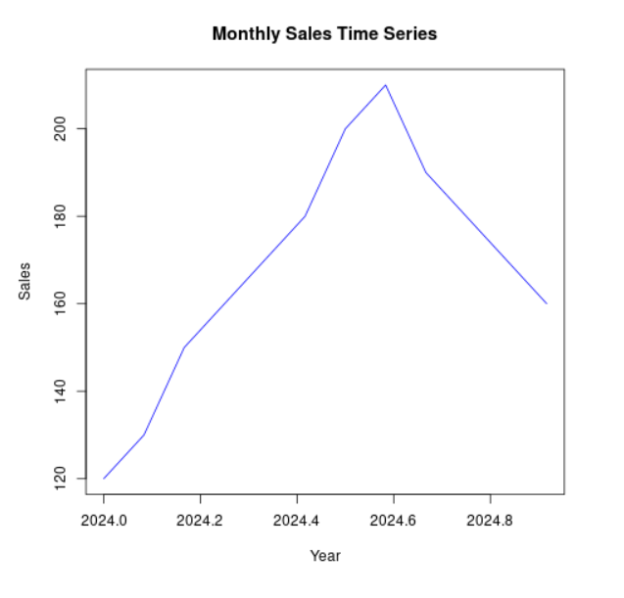
WORKING WITH DATABASES USING RSQLITE:
#install.packages("RSQLite")
library(RSQLite)
con <- dbConnect(SQLite(), "students.db")
query_create <- "
CREATE TABLE IF NOT EXISTS student (
id INTEGER PRIMARY KEY,
name TEXT,
marks INTEGER
);
"
dbExecute(con, query_create)
dbExecute(con, "INSERT INTO student (name, marks) VALUES ('Adiba', 85);")
dbExecute(con, "INSERT INTO student (name, marks) VALUES ('Khushboo', 92);")
dbExecute(con, "INSERT INTO student (name, marks) VALUES ('Ayesha', 78);")
data <- dbGetQuery(con, "SELECT * FROM student;")
print(data)
dbExecute(con, "UPDATE student SET marks = 95 WHERE name = 'Khushboo';")
dbExecute(con, "DELETE FROM student WHERE name = 'Ayesha';")
final_data <- dbGetQuery(con, "SELECT * FROM student;")
print(final_data)
dbDisconnect(con)
OUTPUT:
[1] 0
[1] 1
[1] 1
[1] 1
id name marks
1 1 Adiba 85
2 2 Khushboo 92
3 3 Ayesha 78
[1] 1
[1] 1
id name marks
1 1 Adiba 85
2 2 Khushboo 95

